BBMP soon to be armed with data to clear illegal dump yards
Bengaluru March 28, 2017 00:00 IST
Updated: March 28, 2017 03:58 IST
Share Article
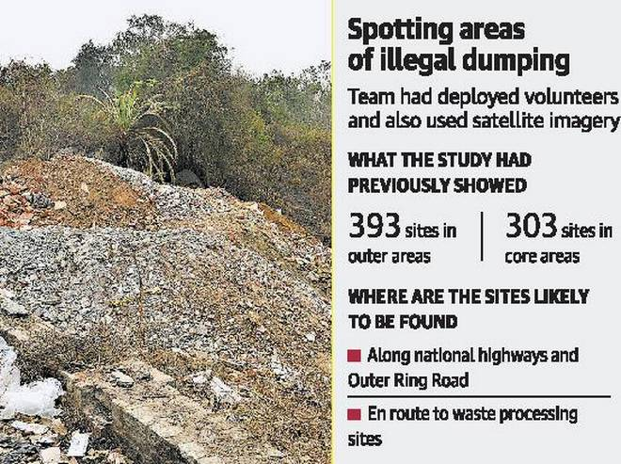

Report on such spots to be submitted in a fortnight
How many illegal dump yards are there in the city? Which areas are susceptible to the furtive dumping of garbage by trucks in the night?
While the Bruhat Bengaluru Mahanagara Palike (BBMP) remains clueless currently to the questions, in a fortnight or so, technology and persistent research may provide them the answers.
Researchers from Indian Institute of Science (IISc.) were roped in by the BBMP in 2010 after facing the heat in the High Court during the hearing of a public interest litigation petition on illegal garbage dumping in the city.
Using a combination of volunteers and satellite imagery, the team — H.N. Chanakya and T.V. Ramachandra from Energy and Wetlands Research Group, IISc. and researcher Shwetmala K. — had mapped illegal dump yards in the city. A staggering 696 dump yards were found — 303 in core areas and 393 in outer areas.
“Using this modelling, we are able to find out factors that make an area or site susceptible to illegal dumping. We will submit this to the BBMP in 15 days or so,” said Dr. Shwetmala. Earlier studies published by the group show that most of these dump yards come within 1.5 km from national highways or major roads, and particularly along the routes taken by garbage trucks towards the processing site.
‘Inefficient system’
Mr. Ramachandra said that with remote sensing satellite imagery being available nearly once a month, a map of the city’s illegal dump yards could be found through an accuracy of up to 2 m. “The civic body has not shown interest because of the prevalent inefficiencies in the system that allow for the garbage mafia to thrive,” he said.
Sarfaraz Khan, Joint Commissioner (Solid Waste Management), BBMP, said that while illegal dump yards were being cleared based on tip-offs by local people, it was a continuous process as these yards continued to pop up.
“Remote sensing data of dump yards in the city today can form the base and a periodic monitoring of the area for new dump yards would be a shot in the arm for enforcement to clear such spots. Satellite imagery can also form acceptable evidence of the crime,” he said.
However, for the civic body, it is the dumping of construction and demolition debris that poses a greater challenge, particularly in areas such as Mahadevapura, Bommanahalli and Kanakapura where a large plots are being rented out only for dumping.

