Supplementary material: e-supplement

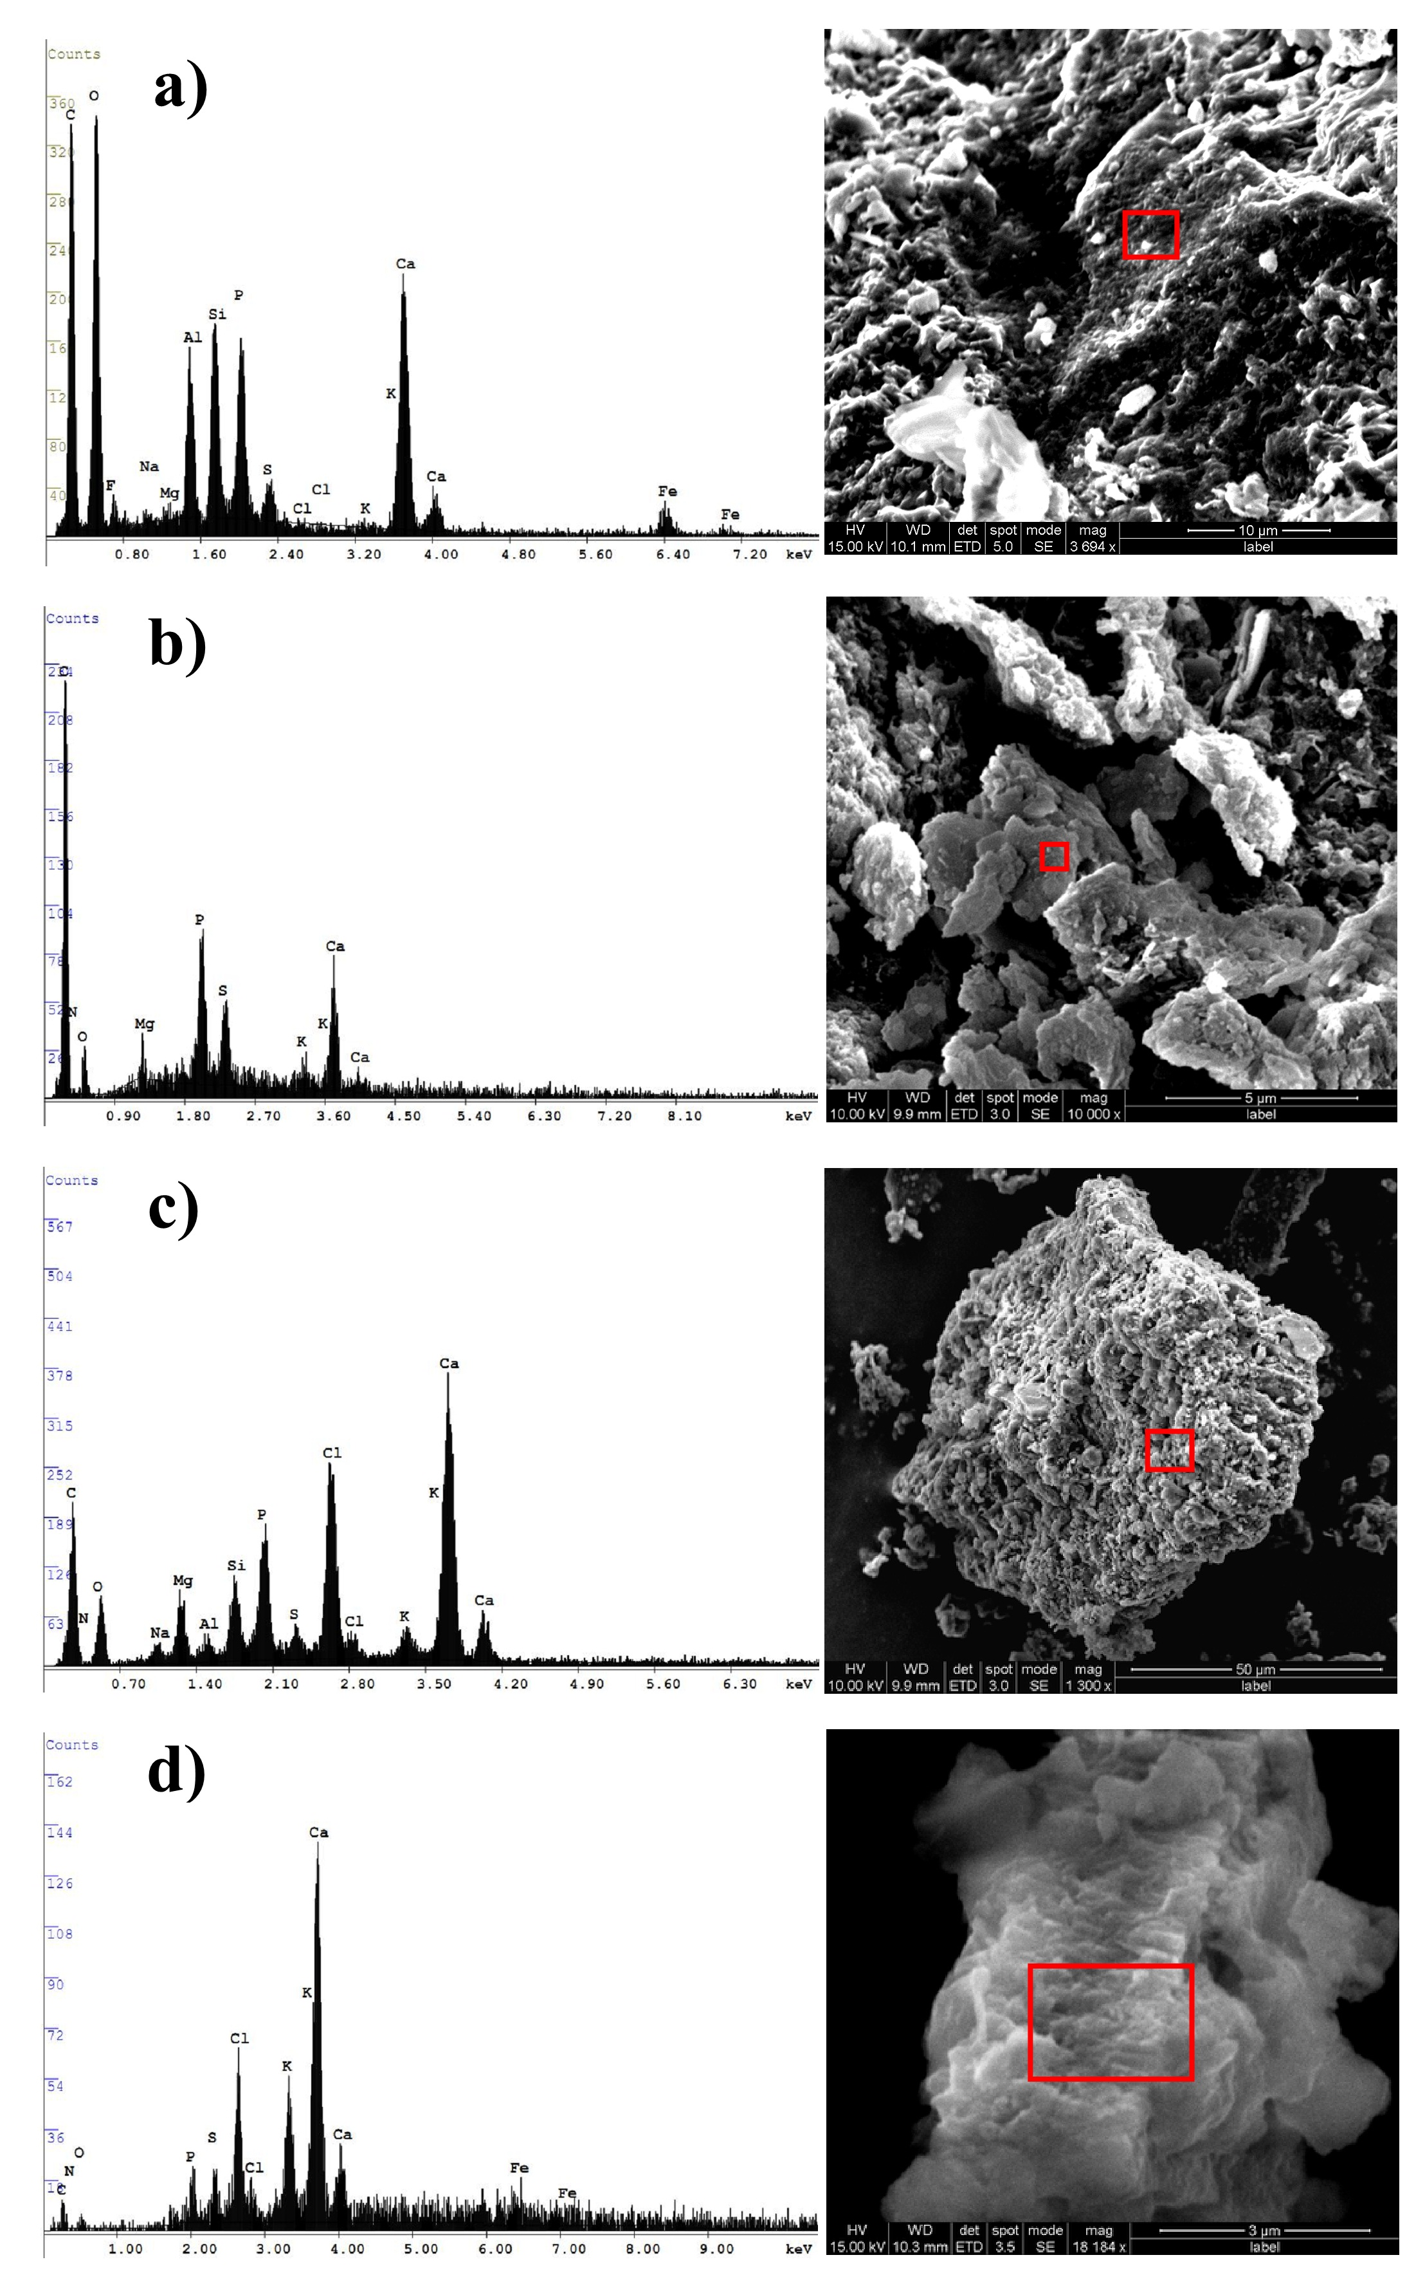

Fig. S1. SEM-EDXA anlysis of Algal types in the reactor a) Algal Scum/flocs; b) Algal cells; c)Algal reactor Sludge and d) Non-algal suspended matter

Table 1. Daily observations on Cellular Macromolecular constituents acquired from bands by FTIR
Day | Cellular  Macromolecules | Value | Err | R²
Day-01 | Carbohydrates | 2.875 | 0.173 | 0.933
 | Phosphates | 0.064 | 0.005 | 0.967
 | Proteins | 0.727 | 0.029 | 0.985
 | Lipids | 0.011 | 0.002 | 0.968
Day-02 | Carbohydrates | 2.683 | 0.145 | 0.939
 | Phosphates | 0.049 | 0.003 | 0.970
 | Proteins | 0.706 | 0.194 | 0.991
 | Lipids | 0.238 | 0.019 | 0.999
Day-03 | Carbohydrates | 2.359 | 0.130 | 0.942
 | Phosphates | 0.077 | 0.003 | 0.915
 | Proteins | 0.528 | 0.024 | 0.985
 | Lipids | 0.385 | 0.212 | 0.989
Day-04 | Carbohydrates | 5.203 | 0.251 | 0.959
 | Phosphates | 0.098 | 0.007 | 0.954
 | Proteins | 1.103 | 0.036 | 0.988
 | Lipids | 0.012 | 0.007 | 0.943
Day-05 | Carbohydrates | 4.459 | 0.259 | 0.931
 | Phosphates | 0.034 | 0.005 | 0.923
 | Proteins | 0.654 | 0.654 | 0.990
 | Lipids | 0.008 | 0.001 | 0.937
Day-06 | Carbohydrates | 3.200 | 0.294 | 0.951
 | Phosphates | 0.033 | 0.013 | 0.912
 | Proteins | 0.452 | 0.017 | 0.988
 | Lipids | 0.031 | 0.005 | 0.957
Day-07 | Carbohydrates | 9.745 | 1.100 | 0.974
 | Phosphates | 0.011 | 0.003 | 0.762
 | Proteins | 0.895 | 0.030 | 0.987
 | Lipids | 0.022 | 0.001 | 0.997
Day-08 | Carbohydrates | 4.413 | 0.195 | 0.978
 | Phosphates | 0.023 | 0.003 | 0.961
 | Proteins | 0.523 | 0.017 | 0.980
 | Lipids | 0.179 | 0.028 | 0.978
Day-09 | Carbohydrates | 3.772 | 0.204 | 0.970
 | Phosphates | 0.019 | 0.001 | 0.923
 | Proteins | 0.408 | 0.012 | 0.989
 | Lipids | 0.102 | 0.012 | 0.975
Day-10 | Carbohydrates | 4.414 | 0.190 | 0.977
 | Phosphates | 0.057 | 0.011 | 0.969
 | Proteins | 0.430 | 0.012 | 0.991
 | Lipids | 0.174 | 0.024 | 0.971
Day-11 | Carbohydrates | 4.068 | 0.186 | 0.976
 | Phosphates | 0.095 | 0.023 | 0.922
 | Proteins | 0.383 | 0.013 | 0.985
 | Lipids | 0.552 | 1.244 | 0.936
Day-12 | Carbohydrates | 3.968 | 0.252 | 0.968
 | Phosphates | 0.094 | 0.088 | 0.961
 | Proteins | 0.219 | 0.010 | 0.966
 | Lipids | 0.673 | 0.267 | 0.924

Table 2. Treatment Parameters before and after treatment with reference values
Physico-chemical and  Treatment Parameters | Before treatment Values | After treatment Values | ª Effluent discharge limits (CPCB)
pH | 6.3±0.1 | 8.6±0.2 | 5.5-9
Redox Potential (ORP) mV | -163±34 | 44±16 | --
Total Volatile Solids (TVS) mg/l | 432±66 | 22±4.7* | --
Total Suspended solids(TSS) mg/l | 540±84 | 26±4.5* | 100
Total Organic Carbon (TOC) mg/l | 219±14 | 31±12 | --
Chemical Oxygen Demand (COD) mg/l | 676±17.2 | 82±12 | 250
Total Nitrogen (TN) mg/l | 64.6±4.2 | 6.66±2 | --
Nitrate-Nitrogen (NO₃-N) mg/l | 1.07±0.15 | 1.54±0.27 | 45
Nitrite-Nitrogen (NO₂-N) mg/l | 0.32±0.04 | 0.21±0.05 | --
Ammonium-Nitrogen (NH₄-N) mg/l | 51.5±5.5 | 5.7±6 2 | --
Total Phosphorus (TP) mg/l | 28±4.3 | 8.26±2.4 | --
Ortho-phosphates (OP) mg/l | 22.2±2.4 | 5.13±1.67 | --

ª Central Pollution Control Board (CPCB) limits for discharging STP effluents into streams (Inland Surface Waters)
*after clarification
#Biochemical Oxygen Demand (BOD) mg/l ➔ 30
#Total dissolved solids (TDS) mg/l ➔ 2100

Ref: http://www.cpcb.nic.in/upload/NewItems/NewItem_195_STP_REPORT.pdf accessed on 22nd Feb 2014.

