Diversity of birds in
Bangalore university campus HAMSINI C and CHARITHAA V GOWDA 8D (CBSE Board)
OBJECTIVE: - To observe and record Diversity of Birds in Bangalore University campus.
Materials and Methods
Study area – Bangalore university campus
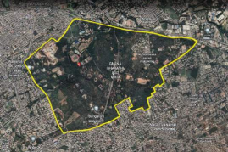• Observation Observation Observation – Weekly twice, early morning and evening. Weekly twice, early morning and evening. Weekly twice, early morning and evening.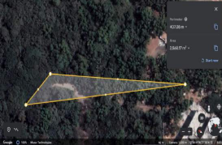 Source : Google Earth
Methodology:
• Observation – Weekly twice early morning and evening. Using Binoculars and smartphone (through 360 degree observing method)
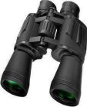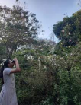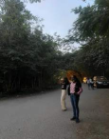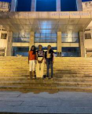• Identification –Information gathered through articles and books about identifying through their characteristics.
Criteria/Morphological features: Feather, neck length, style of feet, beak structure, body structure etc.
• Examine the reasons for the increase or depletion of diversity of birds in the campus. - gathering information through articles and speaking with bird watchers.
Recommendations:
• Since the diversity of birds in Bangalore University campus is agreeable, there is scope for improvement. This can be done by making an anti-pollution area, encouraging nature lovers and bird watchers, providing open resources, and growing more host plants.
Conclusion:
• We observed around 20 to 30 species of birds, which includes migratory and water birds. • Identification through birds’ features helped us to learn and recognize birds. • The species of water birds were comparatively less.
• Through various articles we can say that the diversity is increasing every year. • Reasons for diversity include, good environment, pollution less area, host plants.
References:
• T V Ramachandra, Harish Bhat et al. 2008, ‘Water Bird Diversity at the Tanks of North Bangalore’ Environmental Education for Ecosystem Conservation. 121-126.
• Garima Bhatia and Suhel Quader, Birds of Peninsular India, nature conservation foundation. • Melally G Venkatesh, 2011, Birds of Bangalore University Campus, Salim Ali Centre for Ornithology and National History Coimbatore, India.
Results and Discussion:
NAME | Characteristics | Activity | Image
House crow | Noisy birds with long straight bills Sitting |  | 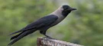
Greater Coucal | Shy birds with a booming call | Feeding
Rock Dove | Have stout bodies with short necks | Feeding
Common prinia | Have long tails | Sitting
Common  moorhen | Look like small ducks but lack webbed feet | swimming
Indian Peafowl | Heavy birds that make short flights | Standing
Great Tit | Very active birds with small beaks | Eating
Black Kite | Hawk like birds often seen  around human habitation | Flying
Spotted Owlet | Mainly nocturnal and roost in large trees and abandoned buildings during the day | Resting
Common Myna | Make various screeching calls and feed mostly on the ground. They roost in large groups | Building  Nest
Indian Roller | Often perch on a low branch or even overhead wires to watch for ground prey. | Feeding

Image Source: Hardhik Ramesh (hardhik_br) Wildlife Photographer
Acknowledgement-We thank Indian Institute of Science, Energy and Wetland Research Group Scientist T V Ramachandra Sir and all others who gave us chance to learn and present our project as part of lake symposium 2022.We also thank our school and teachers for supporting and helping us in the project.

